**LIFECYCLE OF A PRODUCT**

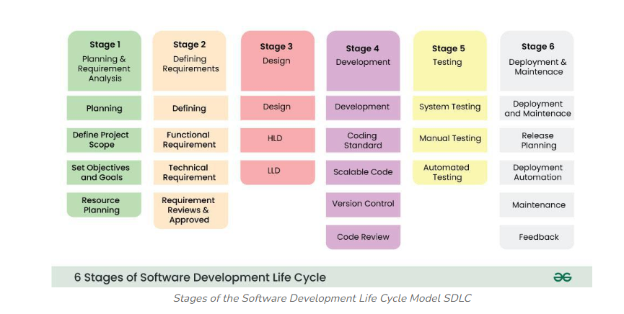

Every product goes through a lifecycle, so we need to plan for each stage. The first stage is Requirement Gathering. Here, business analysts or product analysts collect and analyse requirements. They check for things like clarity, feasibility, and consistency."

Top of Form

Bottom of Form

**STAGE 1:**

**PLANNING AND REQUIREMENT ANALYSIS:**

Planning is crucial in everything, including the software development lifecycle. In this stage, we perform requirement analysis. This involves gathering customer input and conducting surveys from sales and marketing departments.

The information gathered forms the foundation of requirement gathering. Good planning always leads to better project quality.

In short, the requirement analysis phase includes:

- Planning

- Defining scope

- Setting objectives and goals

- Resource planning

**STAGE 2: DEFINING THE REQUIREMENT**

BASICALLY making the documentation of the requirement that we have collected is called as defining requirement, approval for this requirement are taken from customer, market analysis and stakeholder This is Fulfilled by using SRS: SRS stands for software Requirement Specification, it is a kind of document that is specify in order to showcase and document all those things that need to be defined and created during entire life cycle make it into easy English

**STAGE 3: DESIGNING**

Next after sirs we proceed with the information In order to create design document specification (DDS)

Now these dads can be of two types

Low level design

High level design

**STAGE 4: DEVELOPING THE PRODUCT (DEVELOPMENT)**

Now in order to convert the dads into a development phase or an actual application we make use of coding languages

**STAGE 5: TESTING**

Using various methods are used in order to track fixed and retest the application

Testing helps in improving the quality of the products

And the actual output is as per as the expected output

**STAGE 6: Deployment and maintenance**

Its consist of project deployment, aftersales supports and maintenance and feedback